**Evaluate the Performance of an E-learning Application Using Jmeter**

**Github Link:**

[**https://github.com/patraasish/Jmeter-Project**](https://github.com/patraasish/Jmeter-Project)

**Project Aim**

**Jmeter**

The Apache JMeter™ application is open source software, a 100% pure Java application designed to load test functional behavior and measure performance. It was originally designed for testing Web Applications but has since expanded to other test functions. Apache JMeter may be used to test performance both on static and dynamic resources, Web dynamic applications. It can be used to simulate a heavy load on a server, group of servers, network or object to test its strength or to analyze overall performance under different load types.

**I used the following:**

* JMeter 5.1.1 version
* Java Development Kit (Version 8)

**URL I test:**

[**www.simplilearn.com**](http://www.simplilearn.com)

**Steps:**

**Step-1:**

First I open jmeter folder then Inside bin folder there is a jar file named as ApacheJmeter and I clicked on it to run jmeter



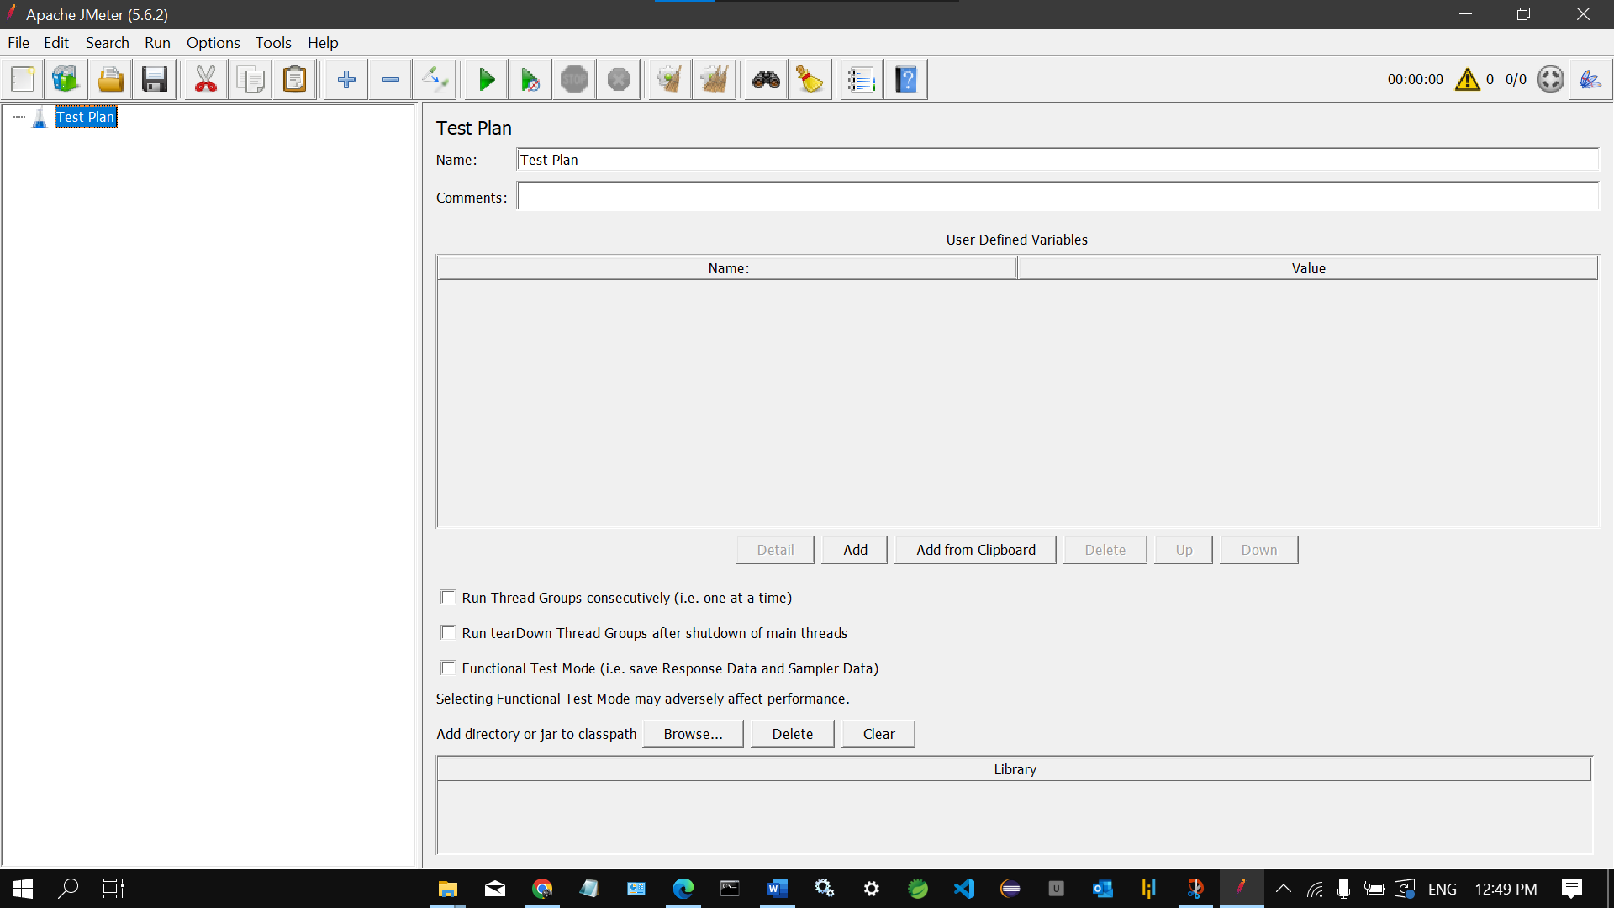

**Step-2:**

Then I open blazemeter extension to record the request url of the simplilearn website

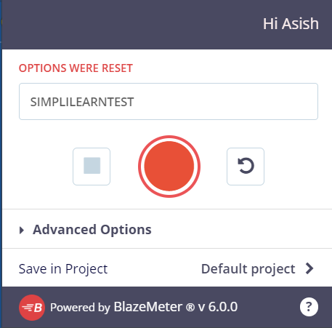





**Step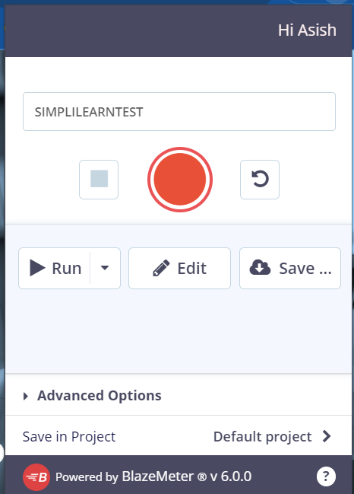-3**: Then I save file as .jmx file

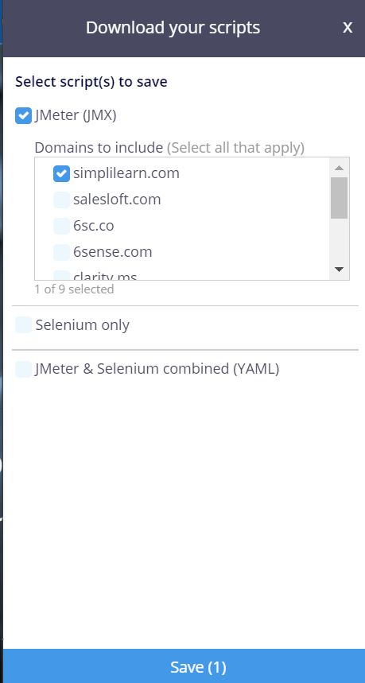

**Step-4:**

Then I open that project in jmeter

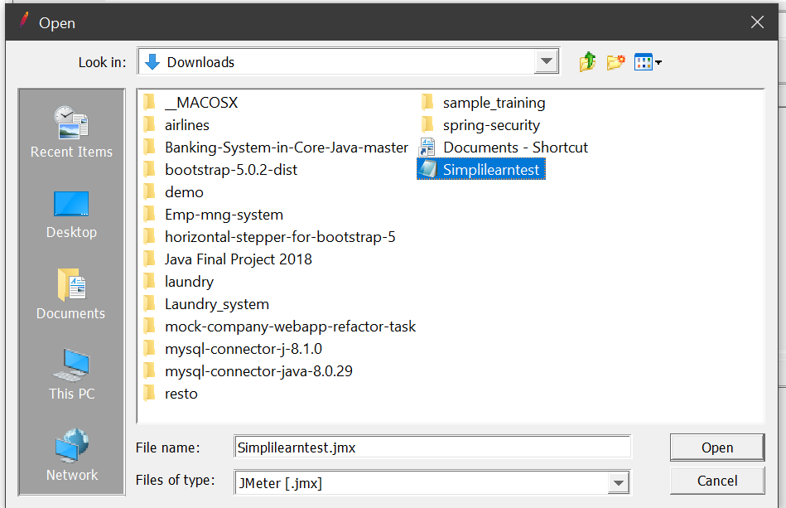

**Step -5:**

Then I create multiple simple controllers

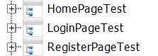

**Step-6:**

Then I add the urls in controllers

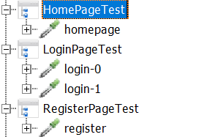

**Step-7:**

Then I add the assertion in HomPageTest Controller

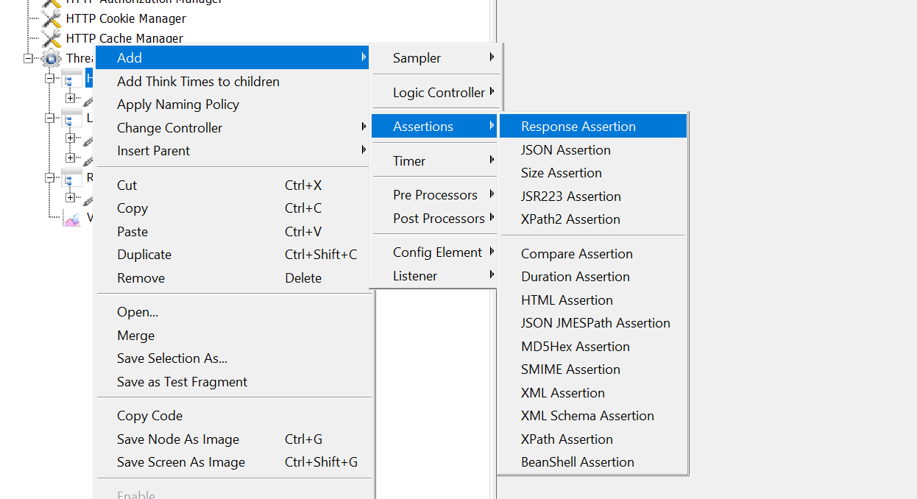

**Step-8:**

Then I add flow control action in HomePageTest

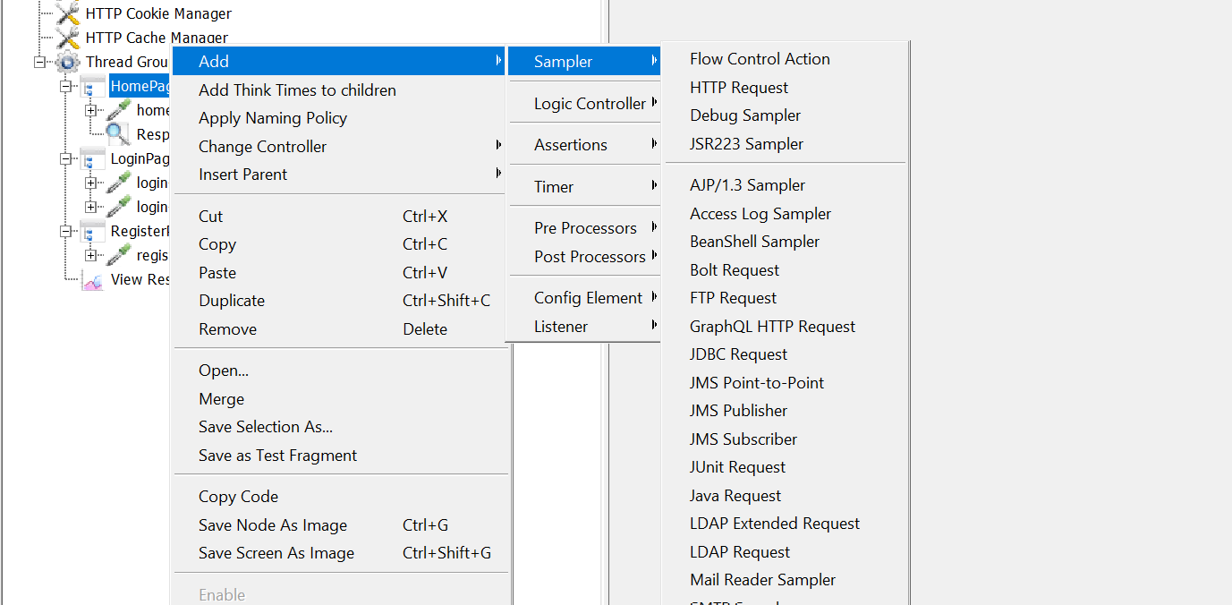

**Step-9:**

Then I add HTML Assertion in LoginPageTest Controller

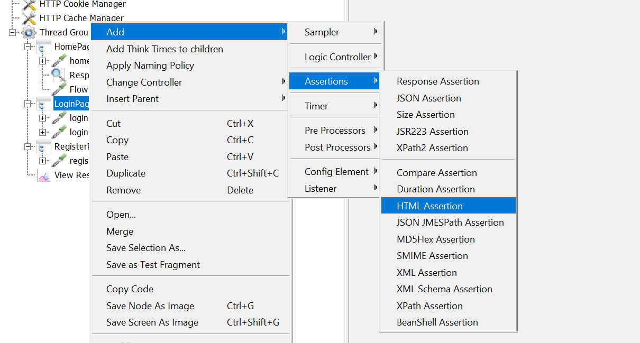

**Step-10:**

Then I create a new text document to save html errors and warnings

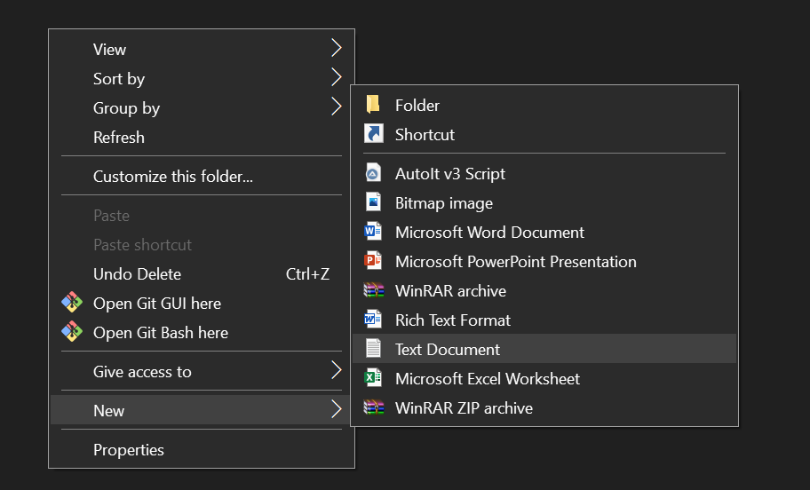



**Step-11:**

Then I add a constant timer in LoginPageTest

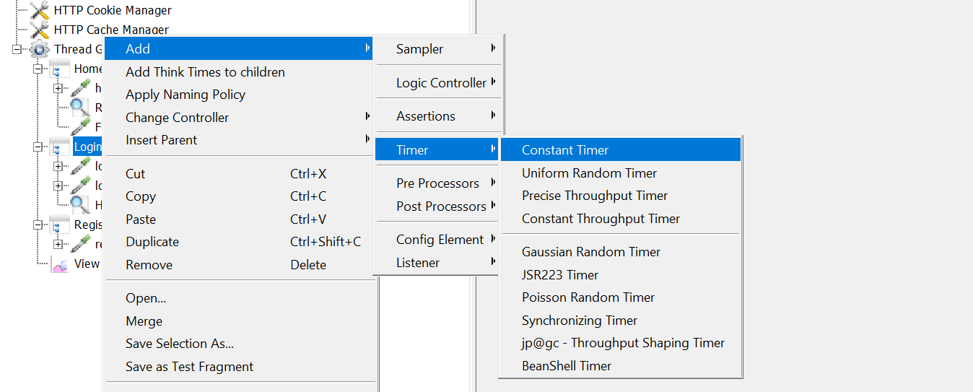

**Step-12:**

Then I add Duration Assertion in RegisterPageTest Controller

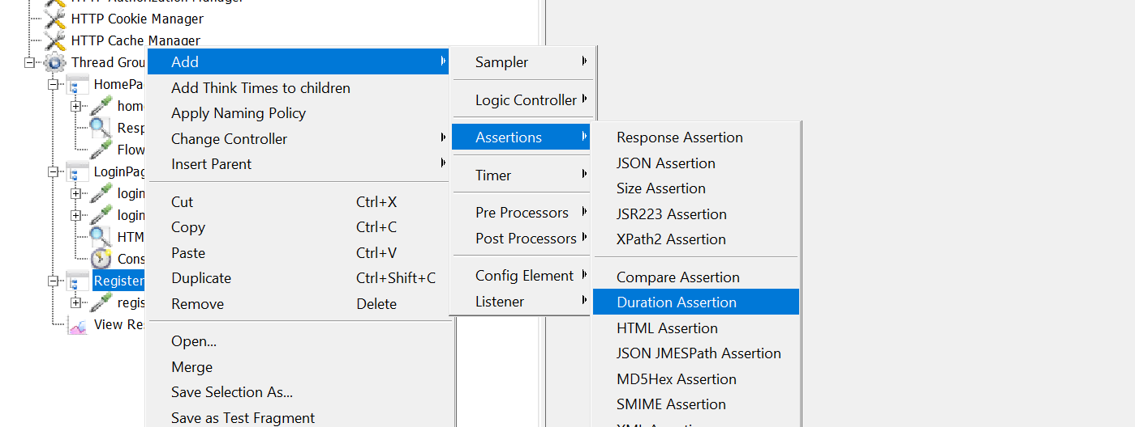

**Step-13:**

Then I add Constant Timer in RegisterPageTest

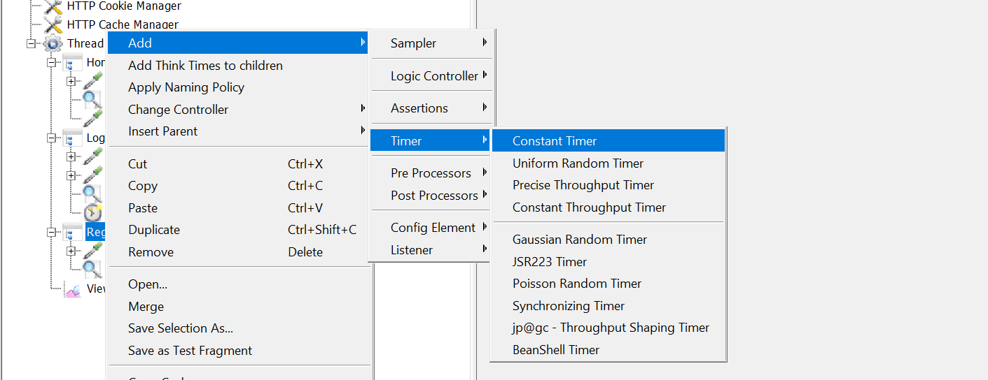

**Step-14:**

Then I add Listeners

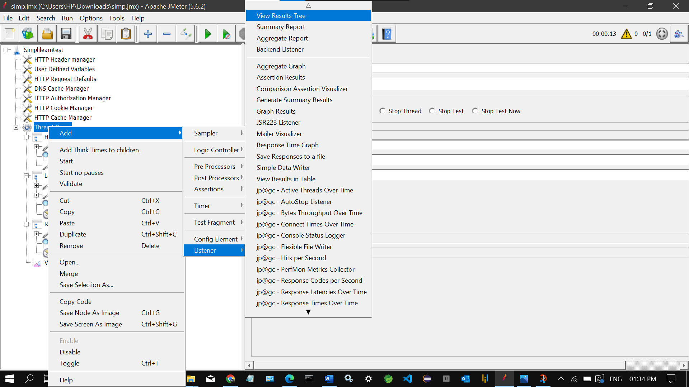

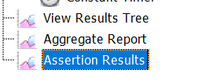

**Step-15:**

Then I Run it

**Step-16:**

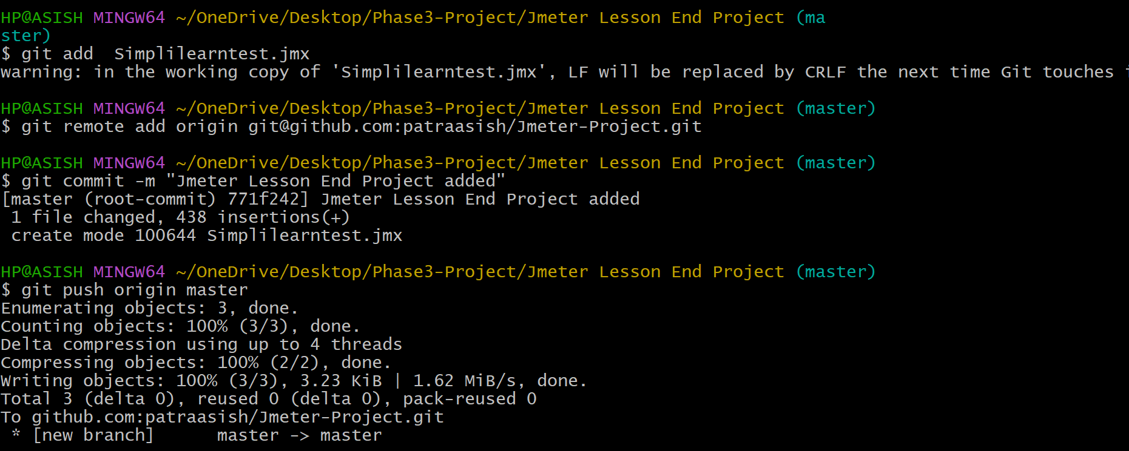Then I push it into my Github repository